Unit 5 Assignment Instructions – CIS164 
For the Unit 5 Assignment we will be working with lists to hold multiple values and our ability to call out those values as needed.
Please make sure to fully read each question to ensure that you answer each question per the requirement. Also, please ensure that all responses are in complete sentences, free of spelling and grammatical errors.
*Unit 5 Grading Rubric (45 Points):
Assignment Requirements | Maximum Points | Points Earned
1. Explain Lists | 0-5 Points
2. Lists - 1 | 0-15 Points
3. Lists - 2 | 0-25 Points
Points Deducted for Spelling or Grammatical Errors
Total (Sum of All Points)
*Directions for Submitting Your Assignment:
Complete your assignment ensuring all questions are answered based on the assignment requirements. When the Unit 5 assignment is complete, please save your file in the following format, “Lastname-Unit#.doc” (Example: Smith-Unit5.doc). You may also utilize a Word Processing software such as LibreOffice for assignment completion. In this case the assignment may be saved in .odt format, (Example: Smith-Unit5.odt). Then when ready submit your file to the “CIS 164 – Unit 5 Submit Assignment” activity for grading.

1. Explain Lists
- What does the value of [-1] refer to in a list?
A value of -1 in a list will be the value in the last index of the list.

- Which operators allow you to determine if a value is in a list or not?

You can use If/in like so:

If value in list:
code here
return;

This compares the value to each index in a list and is true if it finds a match. You can also use a for loop.

2. Lists - 1
- Start the PyCharm IDE. Select “File->New Project” on the next screen. Under “Location” change the word “untitled” to “Unit5”. Then click the “Create” button.

- Highlight your project “Unit5” then right click. When you right click a menu will appear, from this menu select New->Python File. Then a dialog box will appear, in the “Name” field of the dialog box type “Unit5List1.py”.

- Within your Unit5List1.py file, create a list that contains the values for each day of the week. For example; ‘Sunday’, ‘Monday’, ‘Tuesday’, etc…..

- Modify your Unit5List1.py file to have a for loop that prints out each day of the week contained within your list.

- Next, modify your Unit5List1.py file to ask for input from a user to Enter a number for the day of the week they would like to choose (1-7). Then print the output for the day of the week they have chosen from your list. Provide a screenshot of your script and its output when run. Note: Remember in programming list values start at the number zero!

- For your script, you will need to provide a screenshot showing your completed script, and you will also need to submit it in a text file, along with this document.
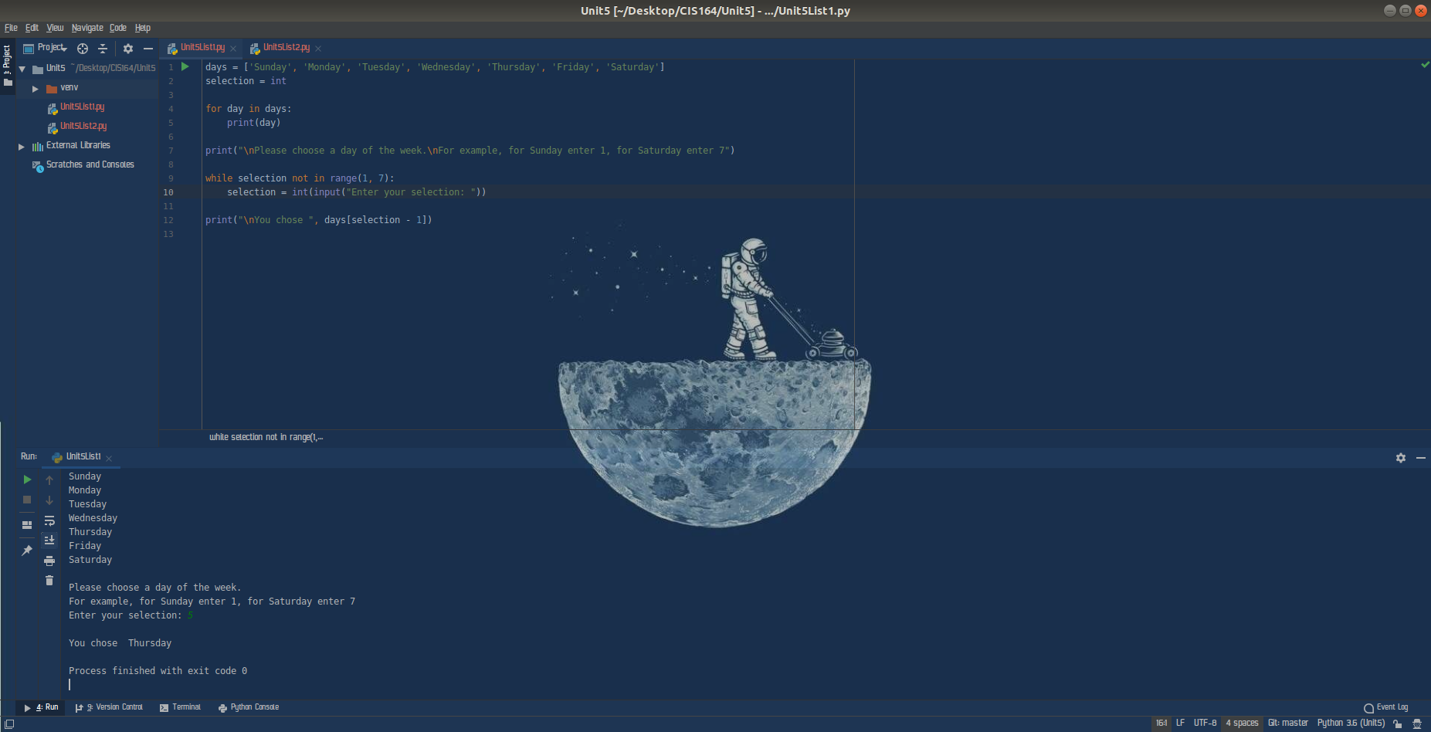

3. Lists - 2
- Highlight your project “Unit5” then right click. When you right click a menu will appear, from this menu select New->Python File. Then a dialog box will appear, in the “Name” field of the dialog box type “Unit5List2.py”.

- Within your Unit5List2.py file, use a while loop to allow a user to enter values for sales, and add each value into a list in order to track all values entered. You can set the gathering of values to stop when the value of zero is entered.

- Next, take your previously created list and calculate the values within the list to return the total for all the values.

- Next, take your previously created list and display all the values in sorted order from smallest to largest. Then display your list in sorted order from largest to smallest.

- Lastly, create a function that will check to see if the value 100 is in the list. If it is in the list simply have the function return, “Yes, 100 is in the list”, if it is not, have the function return, ‘No, 100 is not in the list’.

- For your script, you will need to provide a screenshot showing your completed script, and you will also need to submit it in a text file, along with this document.

